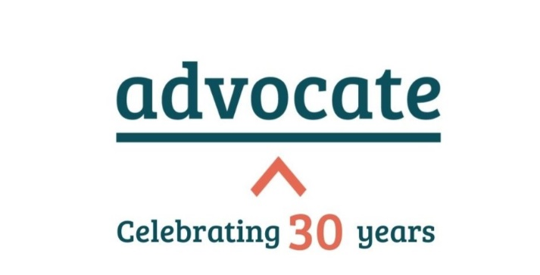

Information for the Northern Circuit

“On the Northern Circuit, I have seen first-hand the real difference that Advocate makes to individuals and families with nowhere else to turn for legal help. Through its casework and on-the-day schemes, Advocate give a voice to those who need it most. I wholeheartedly support Advocate and urge those who can to give, so they can continue making justice truly accessible.” – Sam Hillas KC, Leader of the Northern Circuit

Advocate has been making a difference in communities across England and Wales for 30 years. In the past year more than 5,300 new applications for assistance were received - each representing someone seeking help at a critical moment. As demand for our service continues to grow, your donation ensures that Advocate can continue to grow. Contributions made through the renewal process accounted for 41% of annual funding last year and are crucial to sustaining support for people across Circuit and beyond. To the extent that you can, please support Advocate in continuing to ensure that justice is not a privilege, but a right for all.

Some examples of this life-changing support include:

- Helping a bereaved family with the inquest of their son who died by suicide at a public landmark. Thanks to the barristers’ representation, the site will now be classed as a public authority, and suicide deterrence measures are being put in place to protect lives in the future.
- Finding legal representation for an extremely vulnerable person suffering mental health difficulties in appealing a Land Valuation Tribunal decision after facing a £33k council tax bill that they could not afford. Thanks to our barrister’s support, the person is now liable to pay nothing and will no longer face financial ruin.

Chloe, our Northern Circuit caseworker says:

“We regularly find local counsel to assist with deserving cases. Over the past 3 years we have seen an increase in pro bono assistance on the Northern circuit in all areas of law. In one case, a father based on Circuit faced the most draconian orders possible within the family court through no fault of his own. Four barristers, including two from Manchester, assisted him with his appeal. Without their assistance, the father would have lost all rights to contact with his child. Thanks to their help, the father’s parental responsibility was restored and he was allowed contact with his child. Thanks to the generosity of barristers on Circuit, we can continue to have a life-changing impact on people in need of pro bono support."

