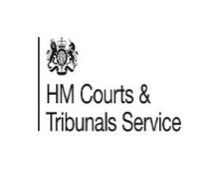  LOCAL FAMILY JUSTICE BOARD LEGAL WALK 2026

4th July 2026 from 10:00am to 16:00pm

THE CITY UNCOVERED
A 10 mile history walk of the City of Manchester through to Salford Quays
Join us for 10 miles or a mile or two.

IN AID OF

THE CHILDRENS BEREAVEMENT SERVICE
BURY HOSPICE


Please donate if possibe to https://www.justgiving.com/page/laura-lightfoot-7?utm_medium=FR&utm_source=CL&utm_campaign=020
If the money we donate helps one child or eases the pain of one parent these funds are well spent.
Please send me yor email addess if you wish to attend. I will them send you the route and you can join in from the start – Victoria Station Manchester or join us on route.

