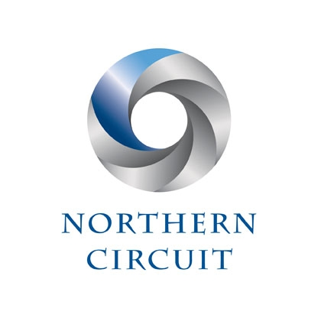
HARDSHIP FUND – DONOR APPLICATION FORM

The Northern Circuit (“the Circuit”) has established the Fund from which it will be able to make grants to members of the Circuit to alleviate cases of serious unexpected financial hardship caused by the loss of work due to the Coronavirus pandemic. It is the intention of the Circuit that after the pandemic the Fund will continue to assist members of Circuit who are experiencing serious financial hardship and/or are in need of financial assistance.
A copy of the Fund’s Rules and Application Form can be found at www.northerncircuit.org.uk in the Covid-19 Section under Finance.
The Fund has been founded using a contribution from the Circuit’s funds and further contributions to the Fund will be considered by the Circuit Executive Committee (“the Committee”).
In view of the number of offers of contribution that have been received it has been decided to open up the Fund to receive contributions from members (present and former) and “friends” of the Circuit.
If you would like to make a contribution to the Fund:
- Please complete this form and send by e-mail to admin@northerncircuit.org.uk with the subject heading “Hardship Fund Donation”
- Payment can be made by bank transfer to the following account: The Northern Circuit Hardship Fund, National Westminster Bank, Sort Code 60-13-19 and Account Number 45366268. Please use your name as your reference.
- If you are unable to make payment via this method please e-mail Clare, Circuit Admin to arrange an alternative method

Name:
Home Address:

Professional Address (if applicable)
Contact Telephone number
Contact E-Mail Address
What is your connection with the Northern Circuit?
Amount of Donation | £

PLEASE NOTE:
- The Circuit acting by the Committee reserves the right to refuse or return a donation in accordance with section 2.3 of the Code of Fundraising Practice where it believes that the acceptance of the same would not be in or accord with the interests and purposes of the Circuit and/or the Fund.
- If you have any query about the Fund, please refer in the first instance to the Circuit Administrator at the e-mail address given above who will refer your query to the Circuit Treasurer or such other appropriate person.
- If you have any complaint about the Fund including the handling of your donation then please refer the same in writing via e-mail to the Circuit Administrator who will refer the same to the Secretary to the Committee who will deal with the same in accordance with the Fund’s Complaints Procedure a copy of which is available at www.northerncircuit.org.uk.
- The data in this form will be used to process and record your donation in the books and records maintained by the Circuit. Thereafter the form will be securely stored for accounting purposes as required by law. Save as aforesaid the fact and amount of your donation will not be publicised.
- A copy of the Circuit’s Privacy Policy is available at www.northerncircuit.org.uk.
- We will only contact you about your donation if we have a query concerning the same or to provide you with a receipt for the same. Unless advised to the contrary all communication will be via e-mail.

